**HOW AN ENGINE WORKS**

4 STROKE CYCLE:

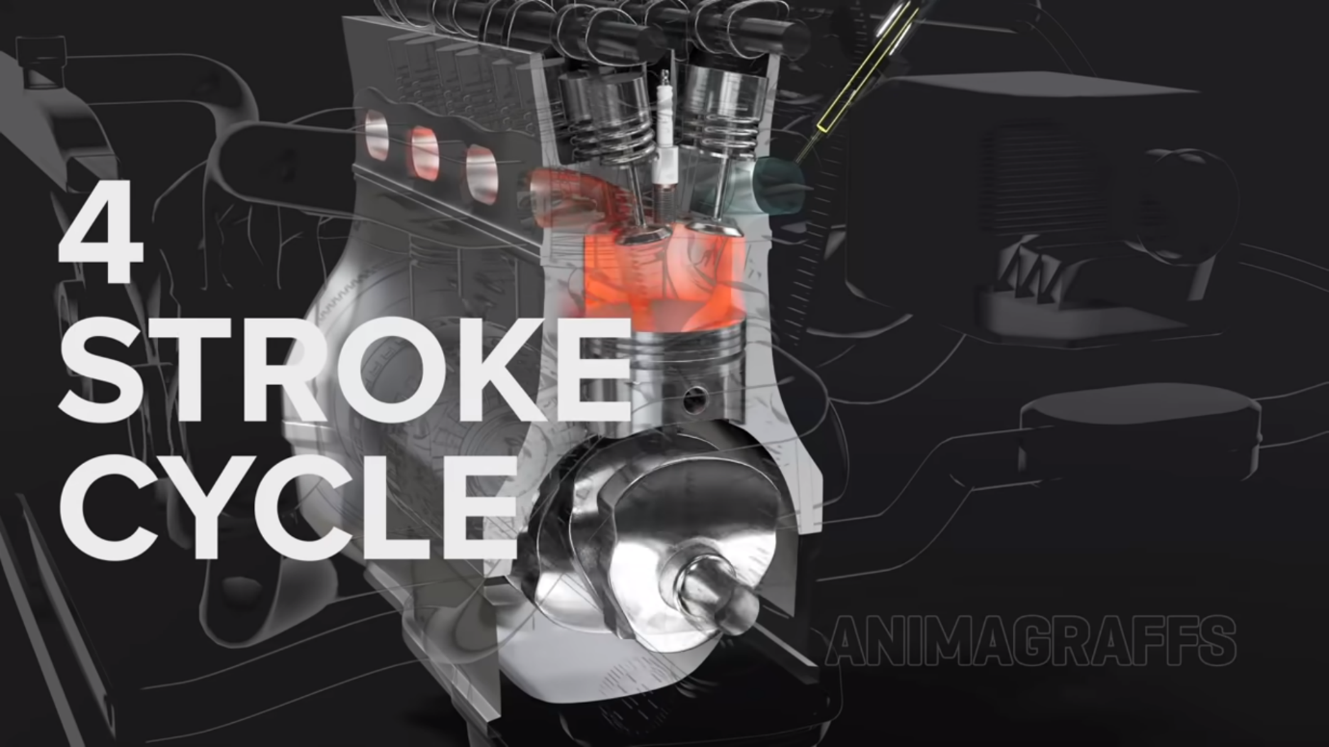

There are four stokes in the min engine which helps the engine to compress the fuel and move the engine.

1ST INTAKE:

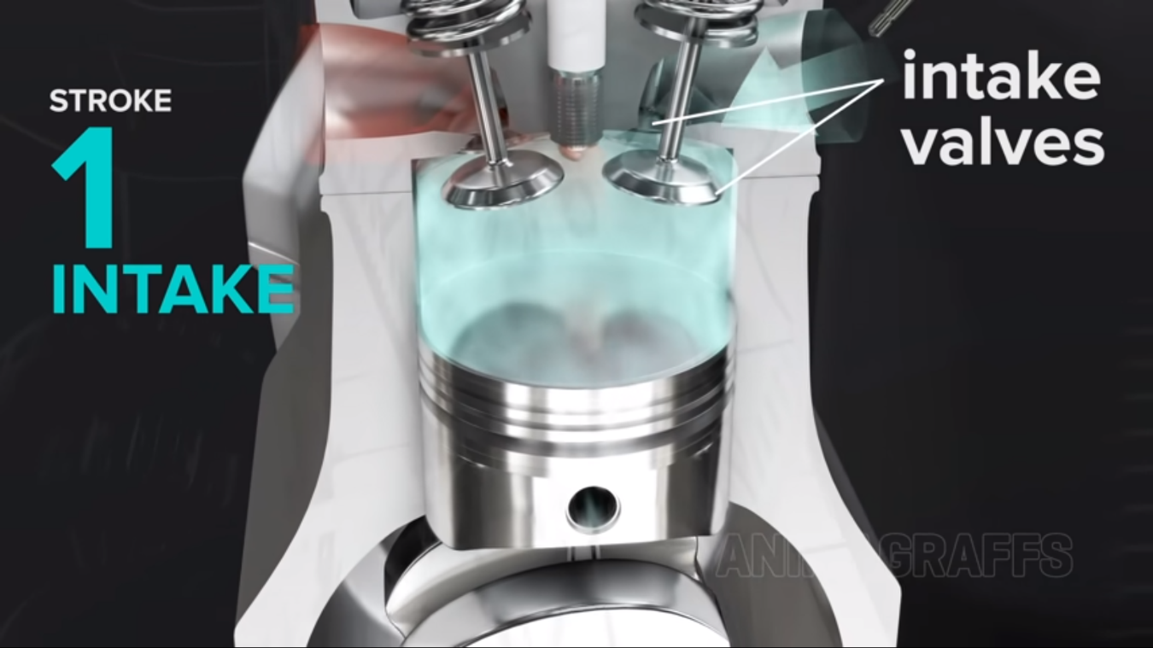

The piston moves down wards and sucks in the air and fuel mixer with the help of intake point. Here all valves are open.

2nd COMPRESSION:  
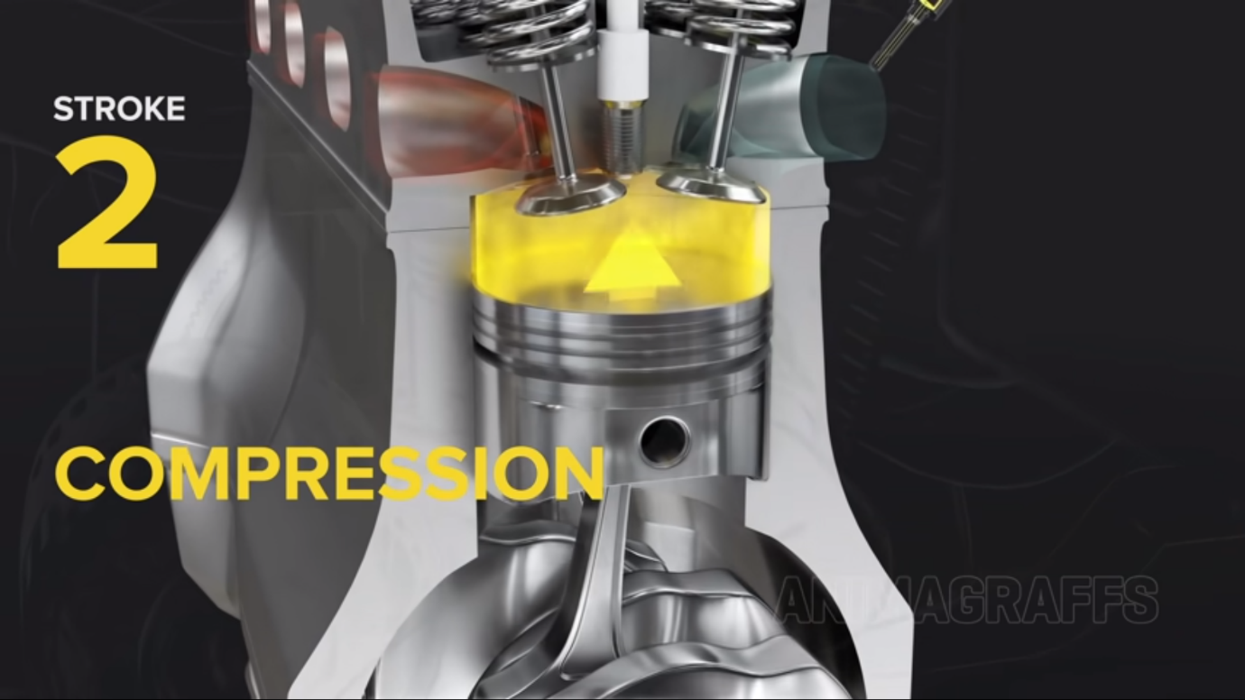

At this stage the piston moves up wards with all valves closed, the fuel and air mixer are compressed.

For more combustion.

3rd POWER STROKE:

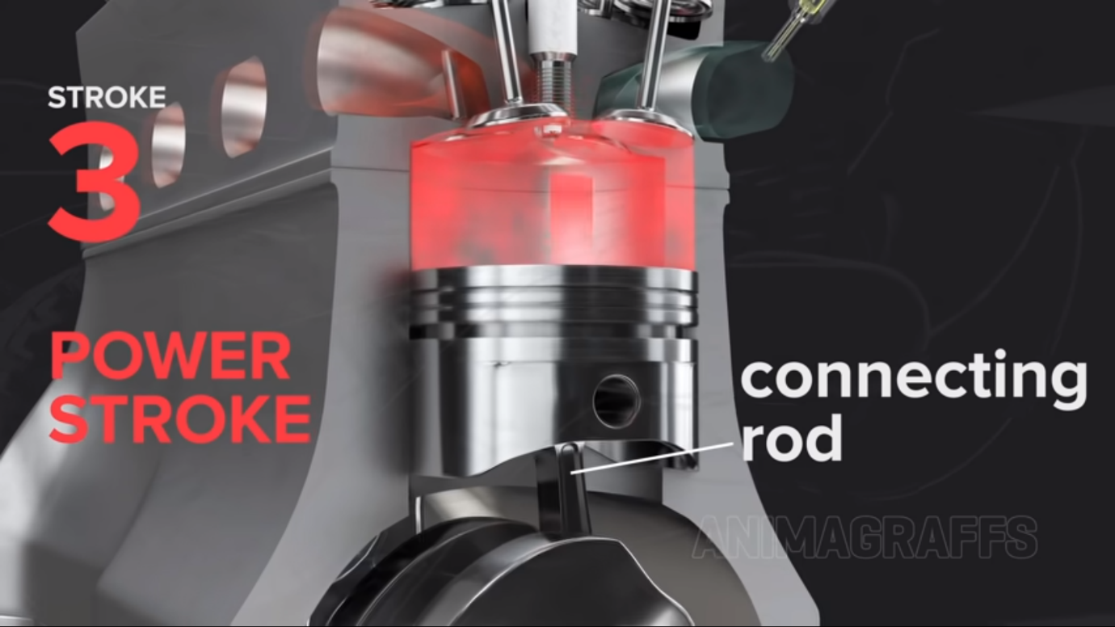

Here when the piston is near the valves the spark plug proves a spark on to the compressed mixture of fuel and air. Which forces the piston to move down wards, makes a mechanical movement. The connecting rod transfers the force to the crankshaft.

4th EXHAUST:

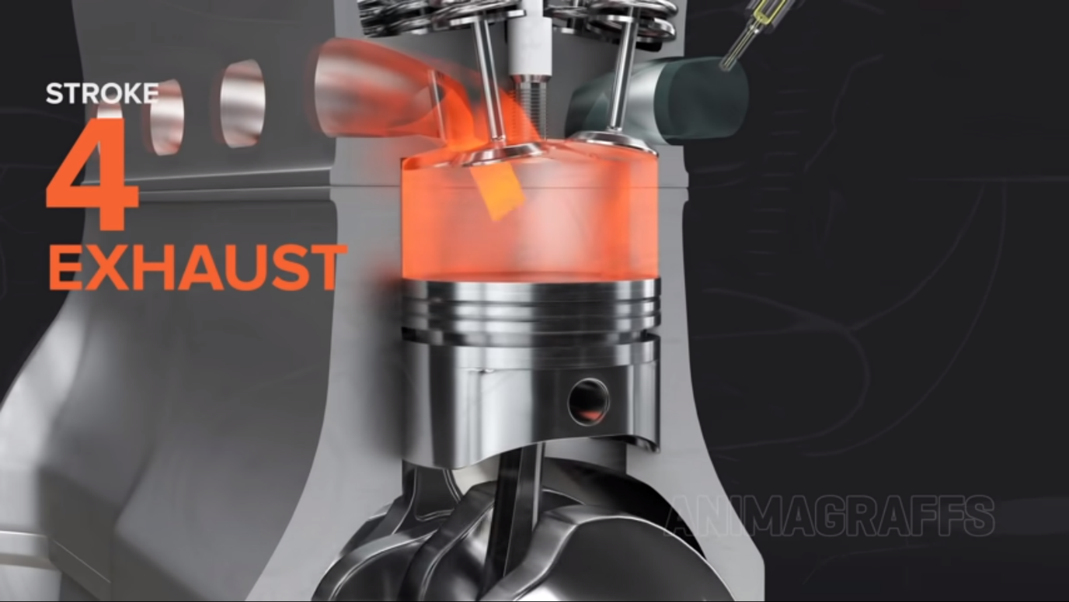

This is the last step; the exhaust valve is open to release the sparked gas through the exhaust port.

For more efficiency we use more pistons, and they take turns firing. There are firing order for every engine.

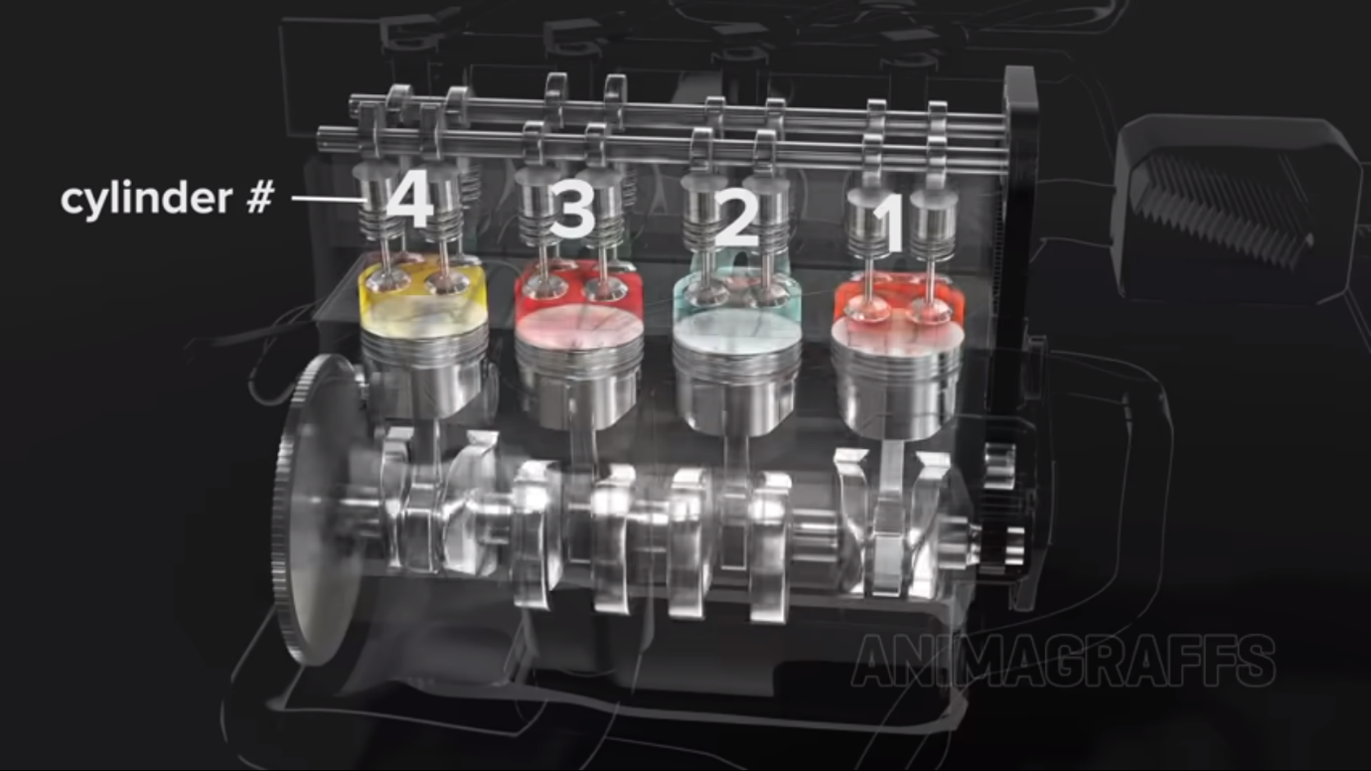

CAMSHAFT:

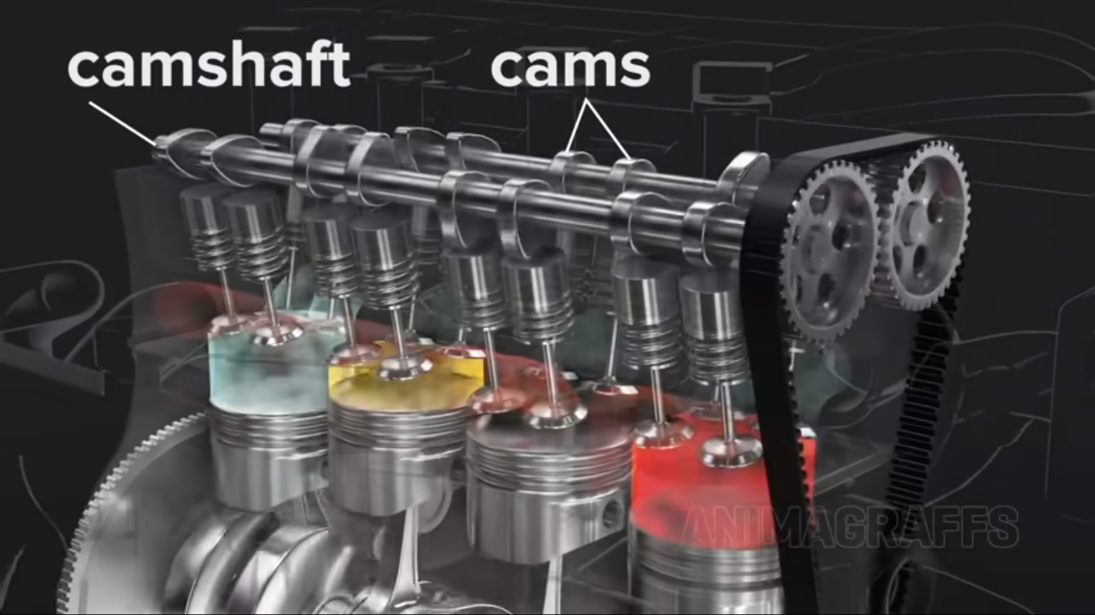

This helps in the timing of intake and exhaust vales i.e for a specific pistonwhen should the exhaust valves should open and when should the intake valves should be opened.It does this job with the help of cams, which push the valves down wardes.

CAM GEARS AND TIMING BELT:  
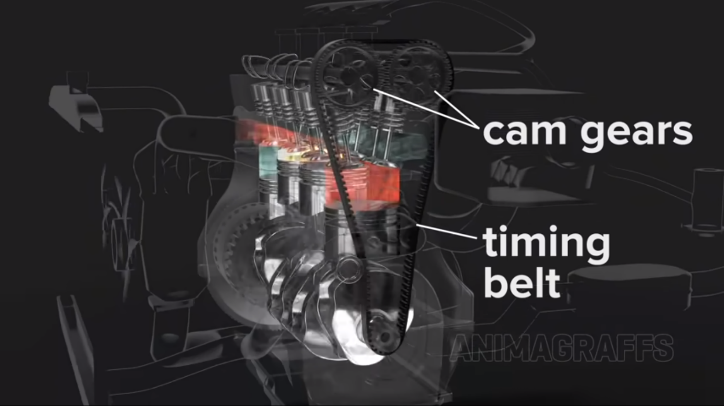

These two will help in the movement of the crankshaft moving the wheels.

CRANKSHAFT:

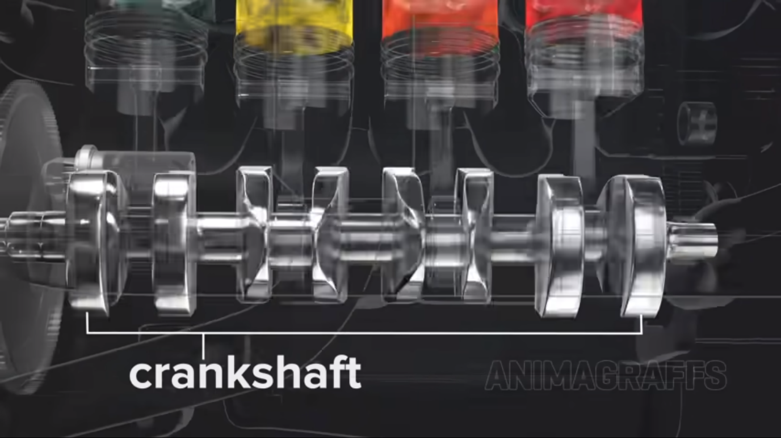

These have a counter weight to balance the movement, with the gravity to push the piston upwards in the process of compression. The complete rotation of crankshaft is known as RPM.

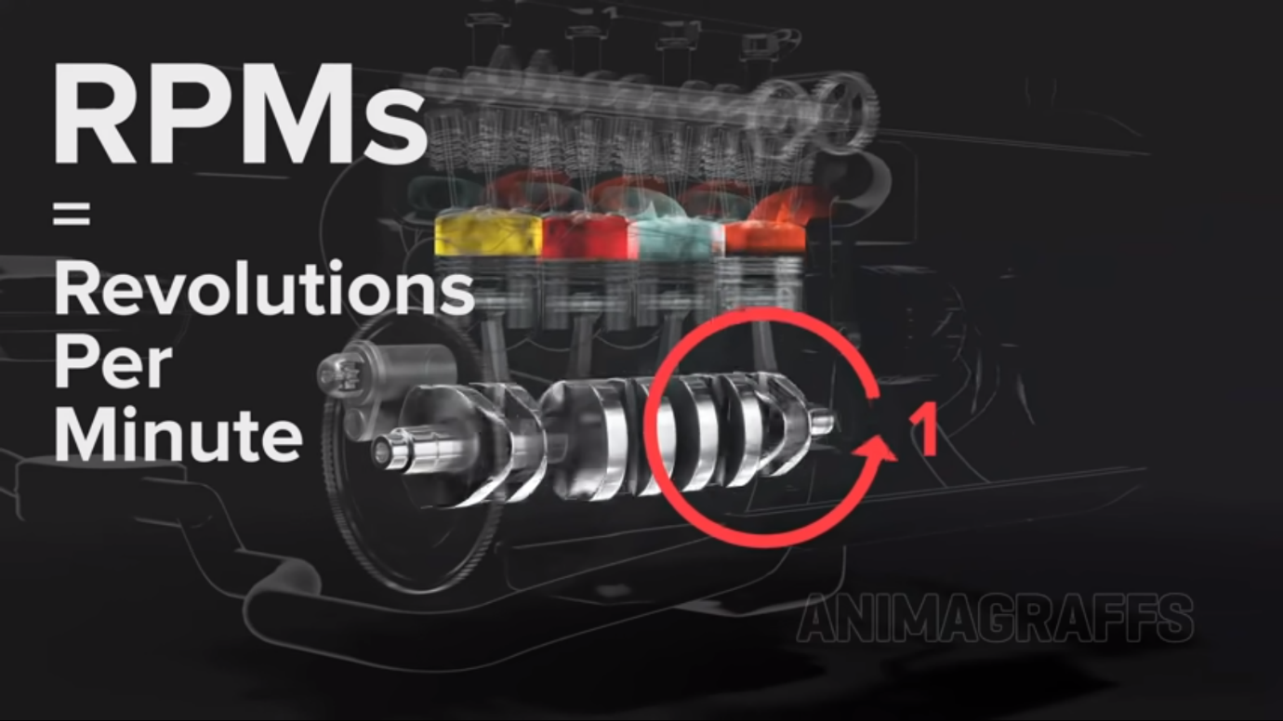

These engine blocks are of many types as V6 AND V8. 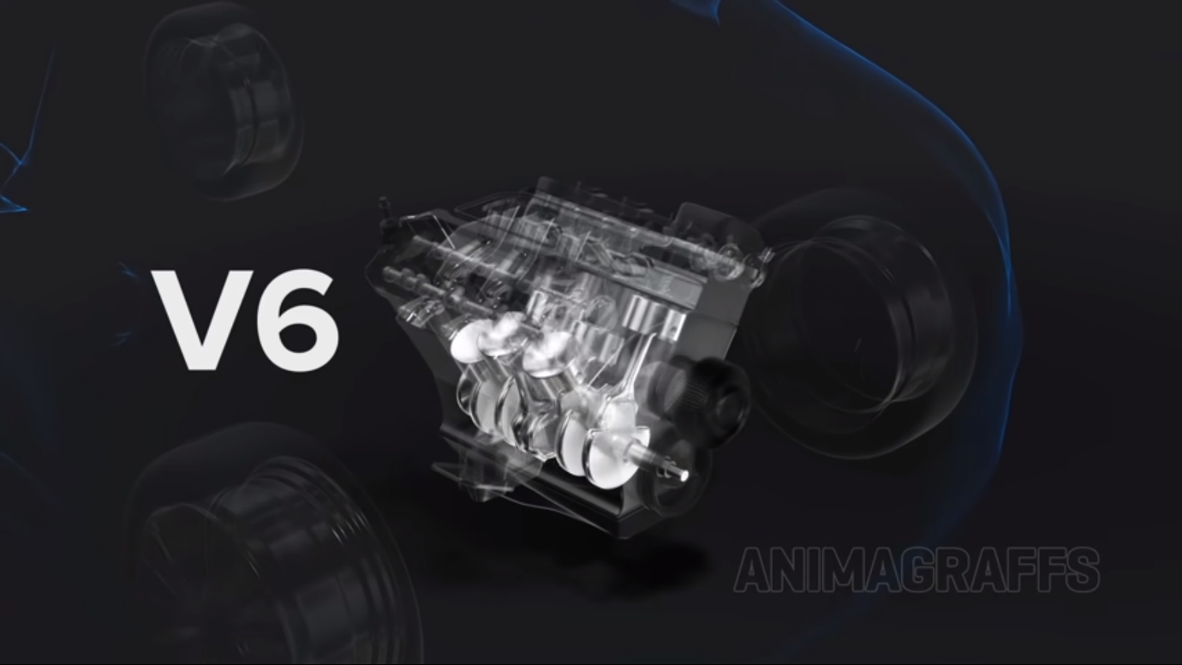

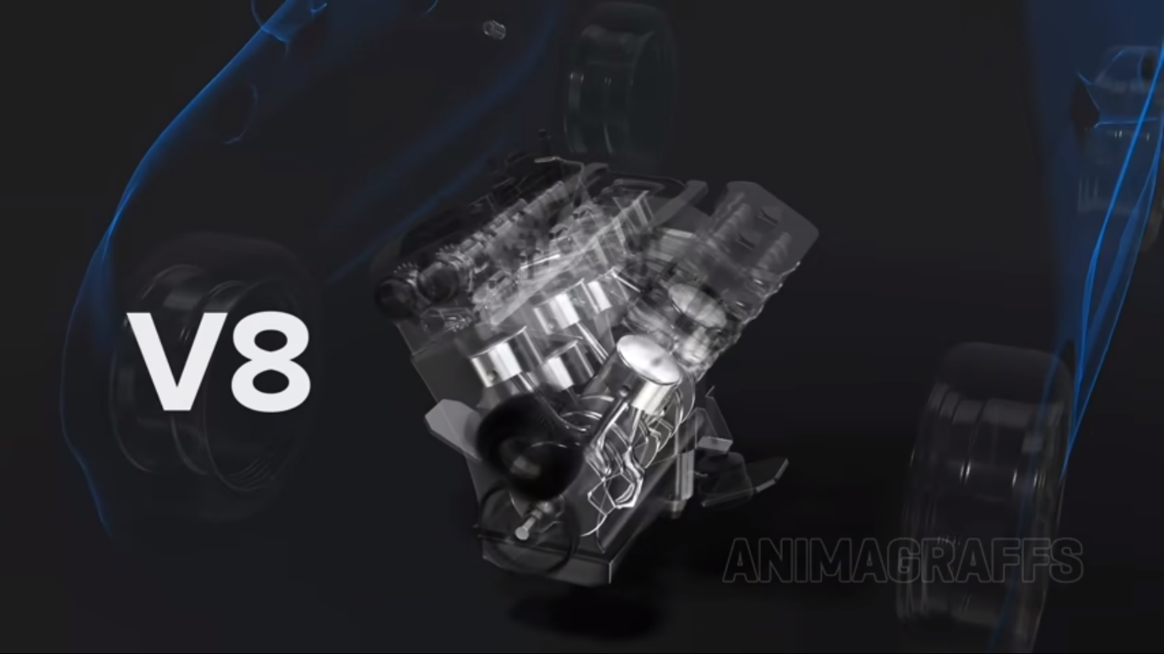

AIR INTAKE:

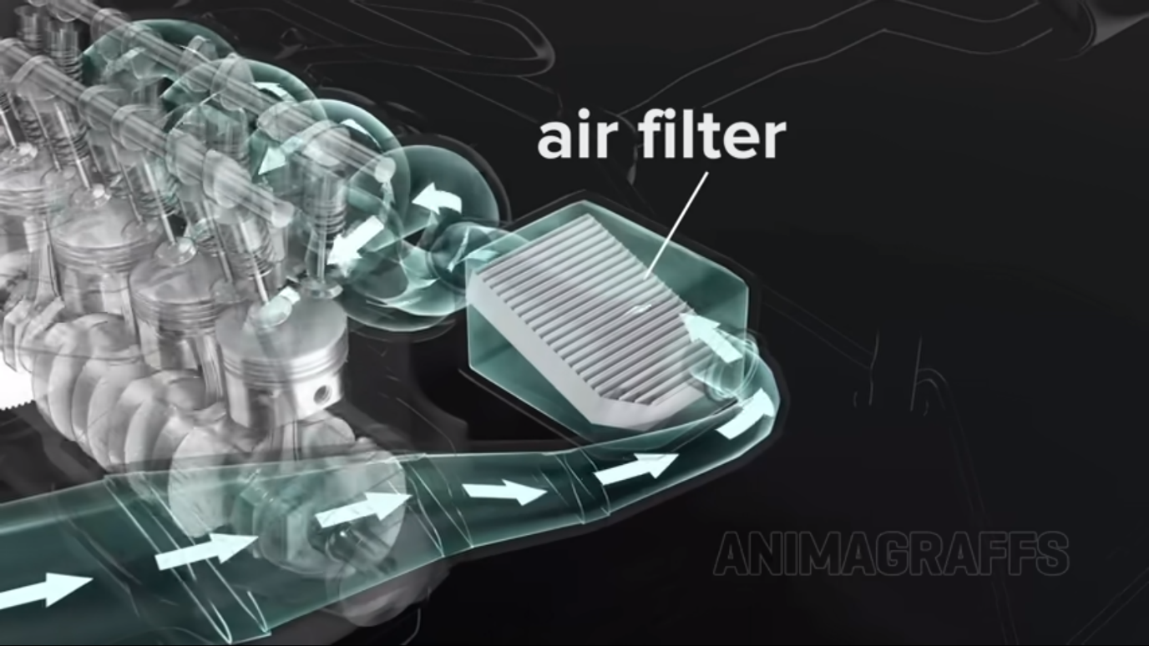

This is the air intake which provides the required in the mixer of fuel and air near the pistons. This contains a very important part called air filter. It moves from intake manifold.

FUEL:

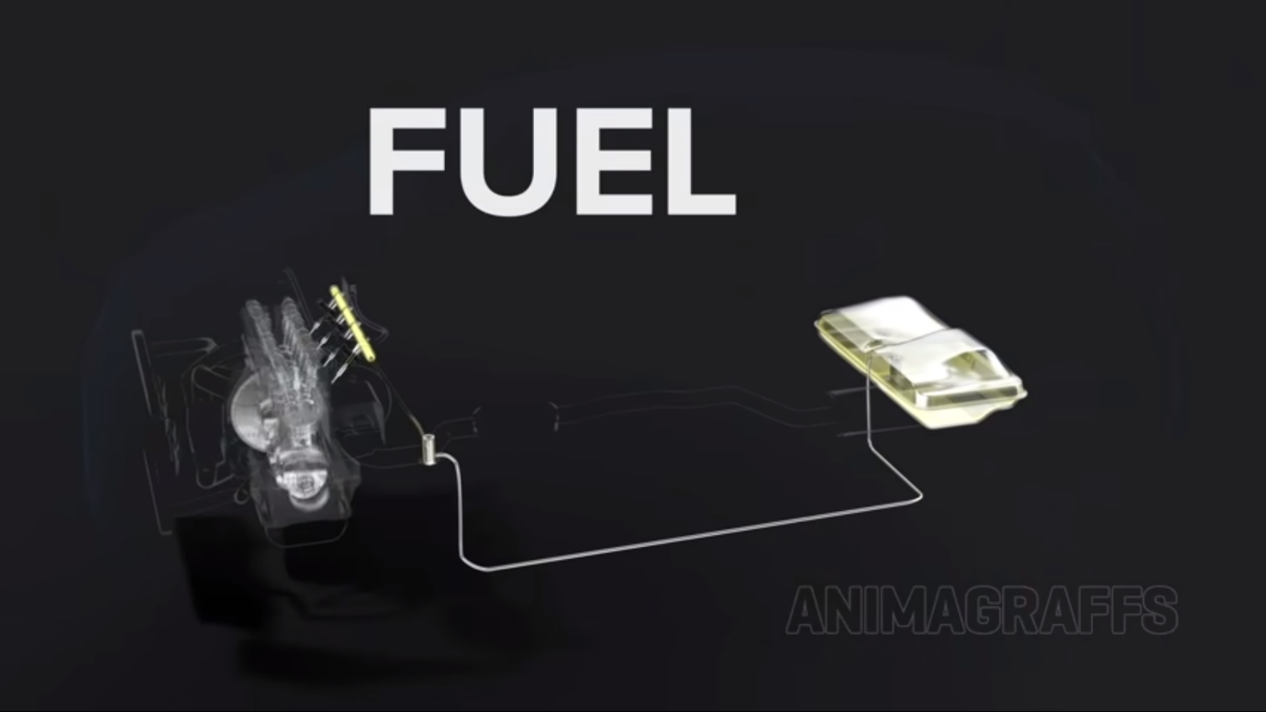

The fuel compartment stores the fuel required for the whole system. This compartment contains three parts that are **fuel pump** which pushes the fuel to the engine block, **fuel filter** this for removing the pollutants in the fuel and then the fuel moves from pipe line which pushes the fuel into the piston which is required for combustion.

**COOLING:**

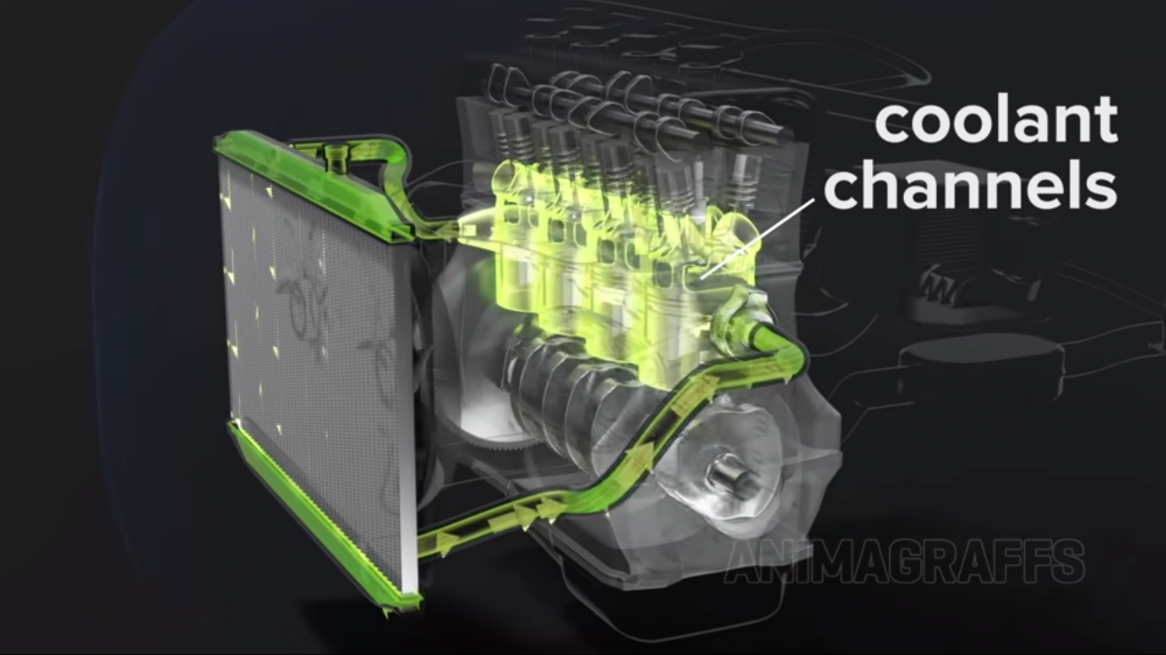

This helps in the prevention of overheating of the engine block, it contains a special liquid called antifreeze to keep the temperature in operating range. After passing through the block, it moves into a mesh containing mesh, the air pulled in by the radiator fan helps in cooling the liquid for reusability.

**ELECTRICAL:**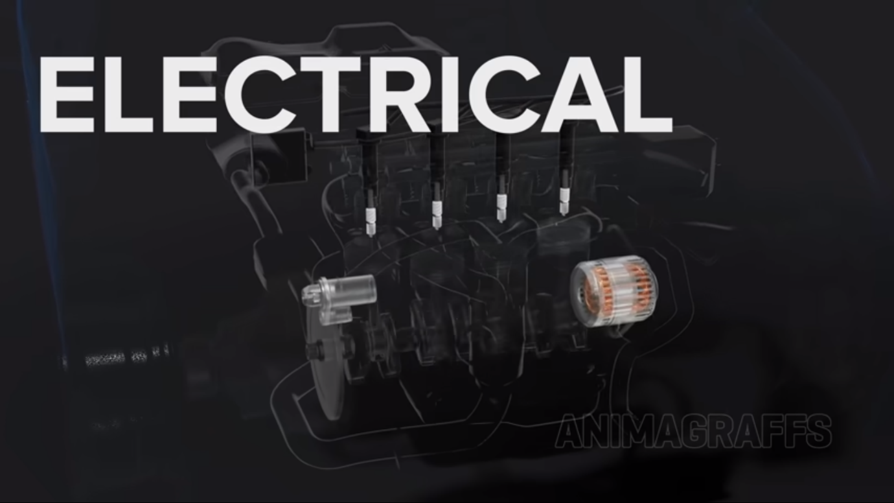

**SPARK PLUG:** Thisprovides the heat required in the combustion process near the pistons.

**COIL PACKS:** This provides the current to the spark plug.

**ECM (ENGINE CONTROL MODULE):** This module helps in coordination of piston movement, valve movement and spark plug working in order. And even the air to fuel ratio.

**ALTERNATOR:** This converts some of the mechanical energy to electricity for the electrically dependent parts in the car.

**BATTERY AND STARTER:** the power from alternator is stored in this battery, the starter gives the initial spark to the engine block to start the engine.

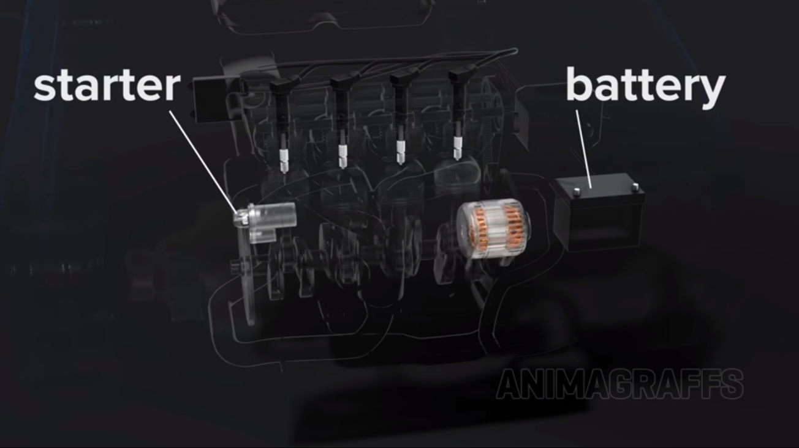

OIL:

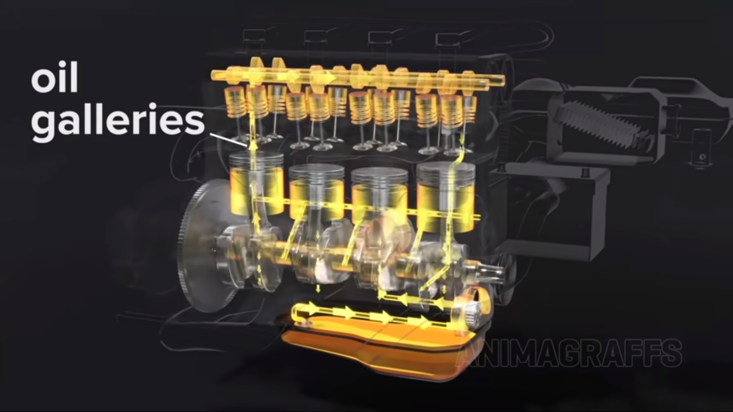

This helps the engine block from escaping from friction due to rapid movement of the pistons during RPM. This has parts such as OIL PAN to store the lubricant, OIL PUMP helps in the pushing the oil throughout the system, OIL FILTER this to protect the engine from the external material.

**EXHAUST:**

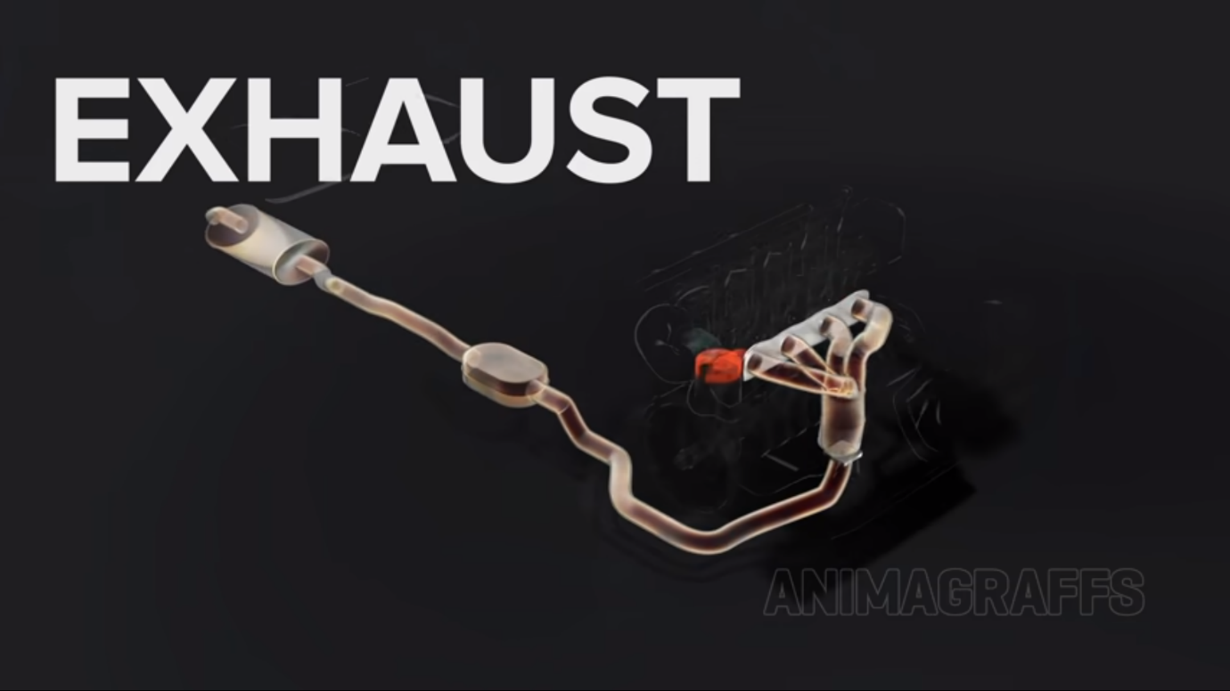

This collects the gas from multiple cylinders into a common pipe using exhaust manifold. Then the air moves into the catalytic converter to remove the harmful substances which could harm the nature, and then at the end it moves out from the muffler.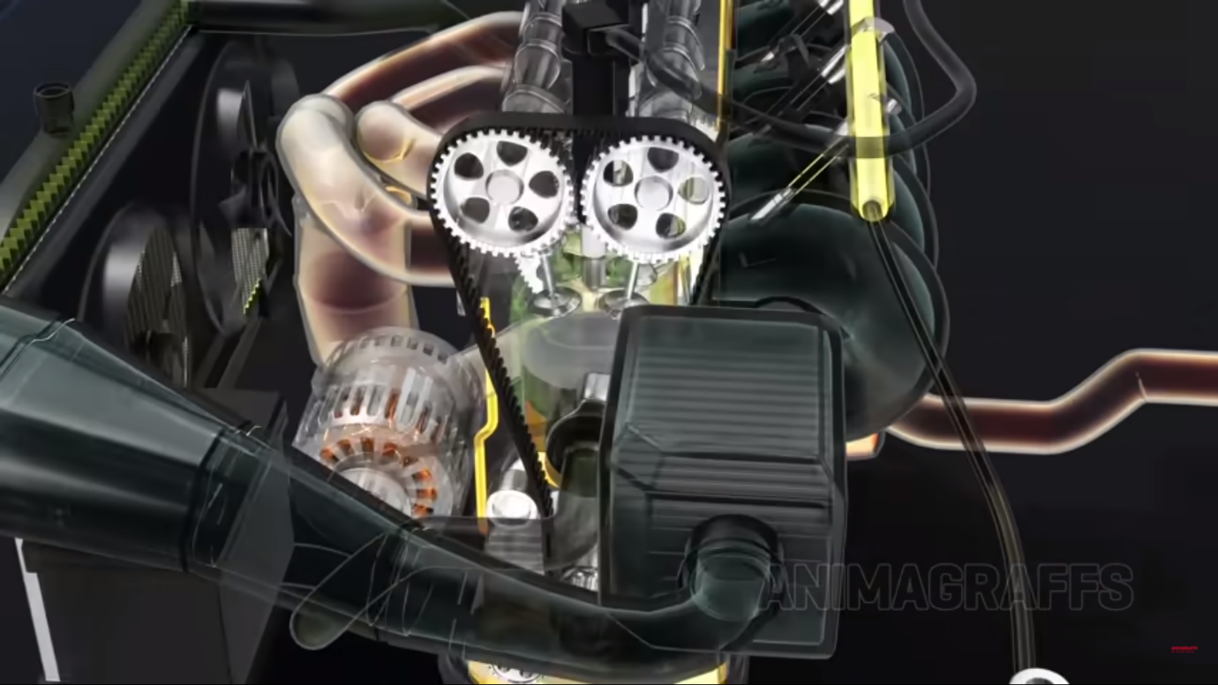

This is the engine oil through out the engine to cool down the engine and stop (or) at least with held the friction and rusting of the engine. While the 4 stroke movement occurs the engine gets rusted (or) damaged due to rapid movement.

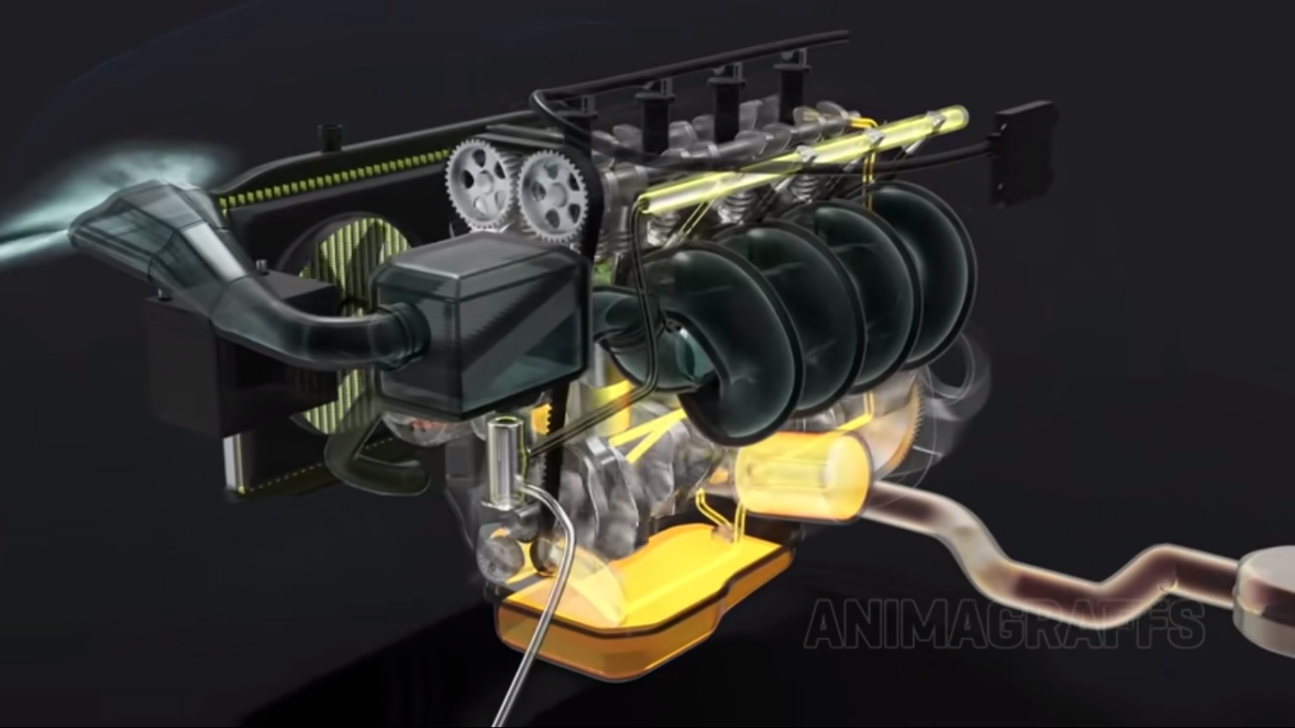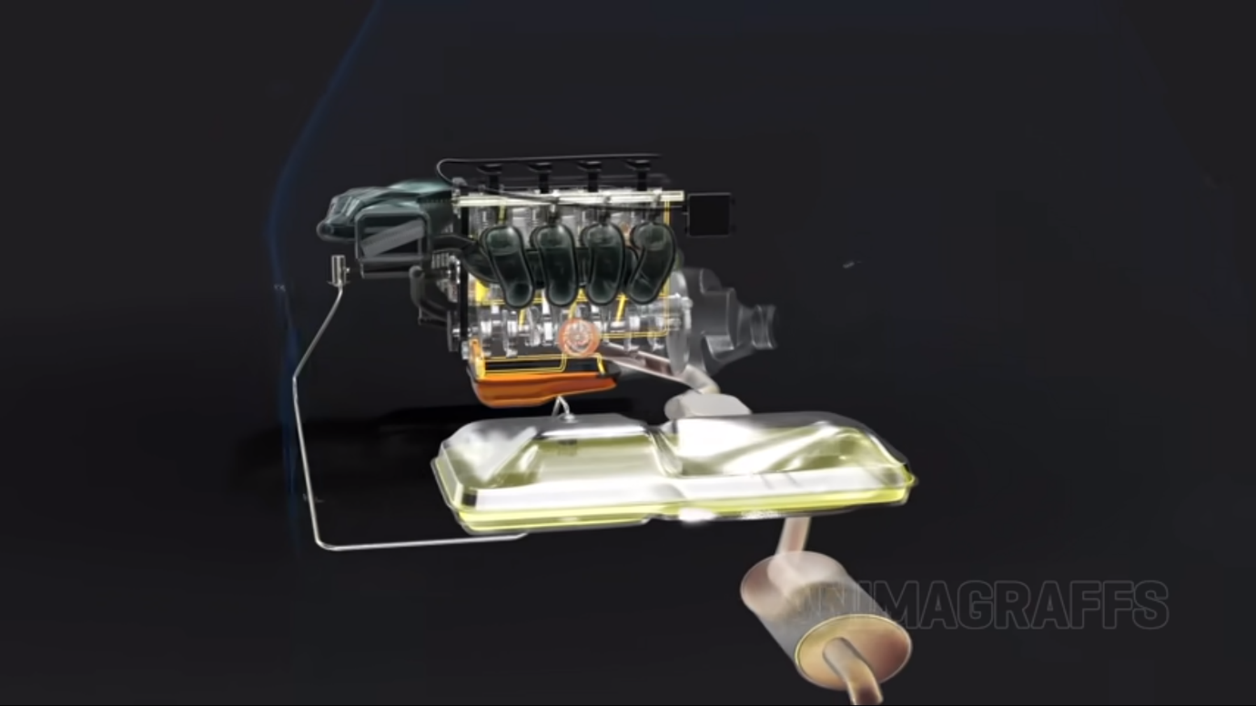

Cool exhaust the heat released by the engine is moved here ad this system (or) component is like mesh which helps the heated up air to move in the maze and the air gets cooled as moved through the maze. At last moved out of the engine.

